Online diary: 10/10/20

The premise of the game was to be the first person out of up to 4 players to gain all available points before the game is over. Playing through the game prompts the user to use his skills of manipulation to double cross their fellow players.

The rules of the game are simplistic within themselves, molding together to create a fun, yet complex game that focuses on strategical progress and razor-sharp wit. Using the dotted board, players must travel across the dots to gain points through the roll of dice. Each subsequent turn, the player must draw a card from one of the piles based on where you are on the board. Whilst the mental skills you need to use are very much strategic based, these rules add an element of luck into the mechanics ensuring that you still have an equal chance of winning whether you’re a seasoned veteran or a newbie to the game. The points system mechanic is an integral part of the game, being the objective to work towards in order to complete the game.

The materials that’s were used to make the game were very simplistic within the creation process, these items were:

* 2 Dice
* 16 player tiles
* 1 Dotted game board
* 64 Cards
* 4 playing pieces
* Notepad and Pencil

Combining these items together with the specific rule set allowed the specific pieces of the game to be part of a much more complex idea.

Place to put the shuffled cards into the center of the board so they are accessible to all players.

Starting areas for every player to place their pieces to begin the game.

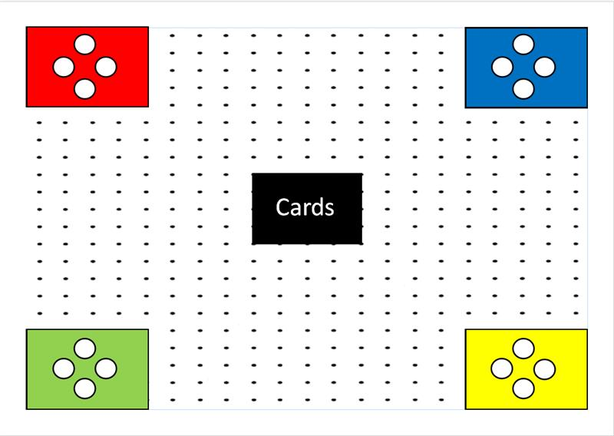

Spaces for the players to move around. Each tile is worth 1 singular point for you. Always stay 2 tile-dots away, else game over for your tile.

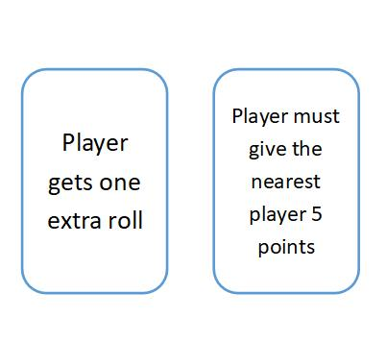

These are the cards that are placed into the middle of the board. These will get drawn by the player and can have either positive or negative effects upon the player and their tiles.

Roll your dice to make your way around the board, collecting points and drawing cards which can either aid or hinder you, depending on the element of luck. You must stay 2 blocks away from any other player otherwise this can result in loss of points and resetting your progress, this idea was created due to the relatability of the game within the current climate of the world.

Due to several time constraints, the game testing took place amongst the group, taking what time we had left to look at each individual aspect and mechanic that was implemented into the game. The results of this testing were very eye opening as it revealed a few mechanics that needed to be tweaked and one major flaw that needed to be addressed in which the cards were too repetitive, thus losing the focus of the players.

Throughout the design and play testing of the game, the communication within the team was high quality, allowing us to easily get our ideas across to one another as well as making sure that all ideas were heard and put across equally. However, I would like to improve our time management as I feel there could have been some legitimate play testing completed if the time had been managed a little better.

The members of the group were: The members of the group were: Samiul Bari, Saira Mahmood and Connor Hadley